Create Image Verification

1. In RFT, click Script🡪 Insert Verification Point  
   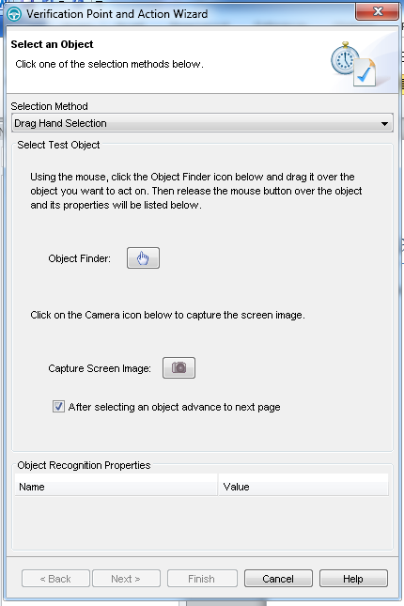
2. Under Selection Method, choose Test Object Browser  
   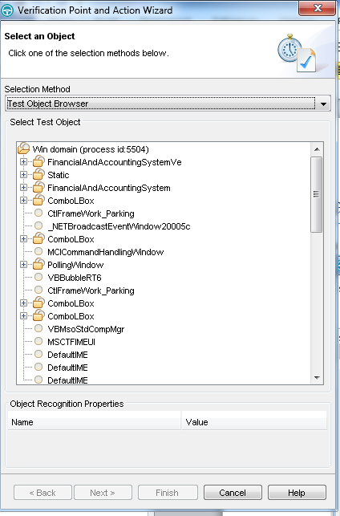
3. Select FinancialAndAccountingSystemVe and click Next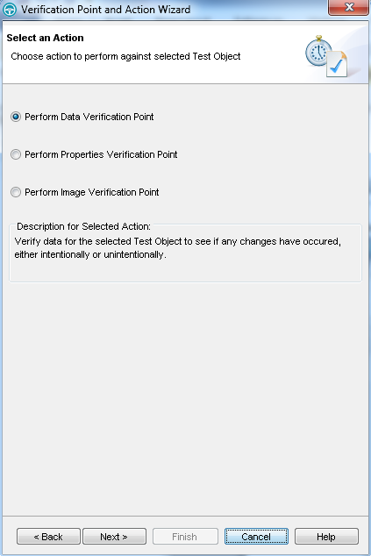
4. Select Perform Image Verification Point and click Next  
   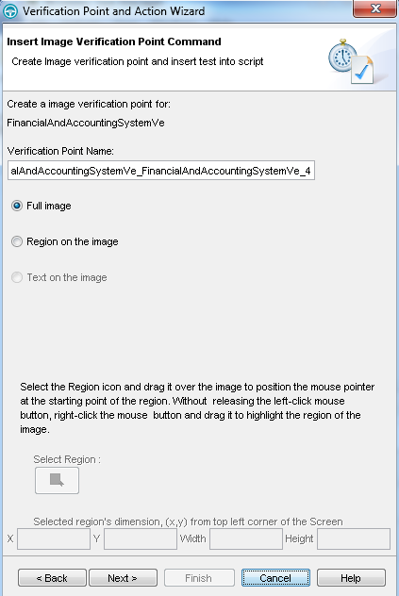
5. Click Next  
   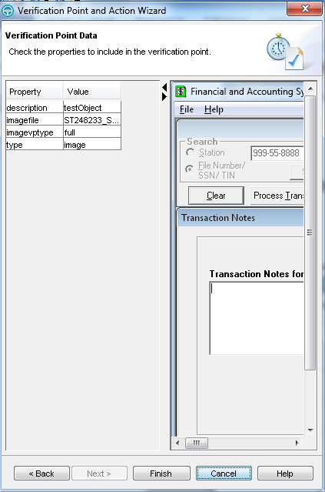
6. Click Finish  
   A statement similar to the above will be entered where your cursor was positioned and verification point will show in Script Explorer: 